Aim: To program Built in Exceptions and Static methods.

Program: https://github.com/rajlaxmi8327/java--lab/tree/main/pgm5

UML Diagram:
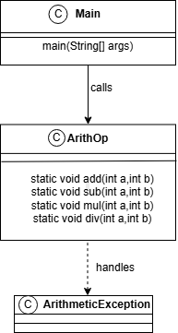

Sequence Diagrams:
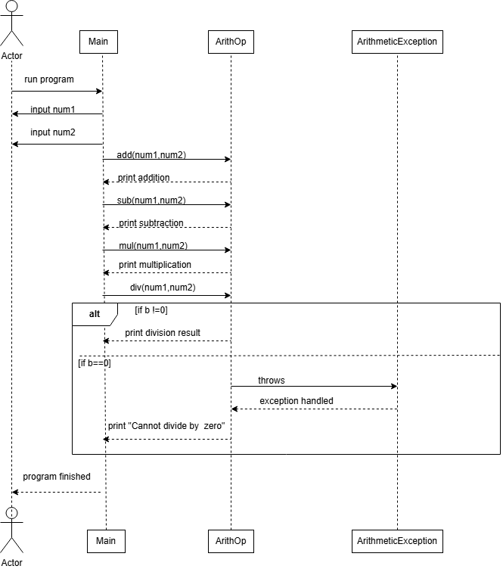

Output:
